Lab Objective

Installing Health Registration Authority Role on an NPS Server

**Lab Procedures**

**1.** Log in to RWDC01 as the **Contoso\administrator** user account. The Server Manager console opens.

**2.** On Server Manager, click Manage and click Add Roles and Features. The Add Roles and Feature Wizard opens.

**3.** On the Before you begin page, click Next.

**4.** Select *Role-based or feature-based installation*, and then click Next.

**5.** On the Select destination server page, click Next.

**6.** On the Select server roles page, expand *Network Policy and Access Services (Installed)*, click to select Health Registration Authority and click Next.

**7.** When you are asked to add features that are required for Health Registration Authority, click Add Features.

**8.** On the Select server roles page, click Next.

**9.** On the Select features page, click Next.

**10.** On the Network Policy and Access Services page, click Next.

**11.** Click *Use the local CA to issue health certificates for this HRA server*. Click Next.

**12.** On the Authentication Requirements page, select the *Yes, required requestors to be authenticated as members of a domain. (recommended)*. Click Next.

**13.** On the Server Authentication Certificate page, make sure Choose an existing certificate for SSL encryption (recommended) is already selected. Click to highlight RWDC01.contoso.com, then click Next.

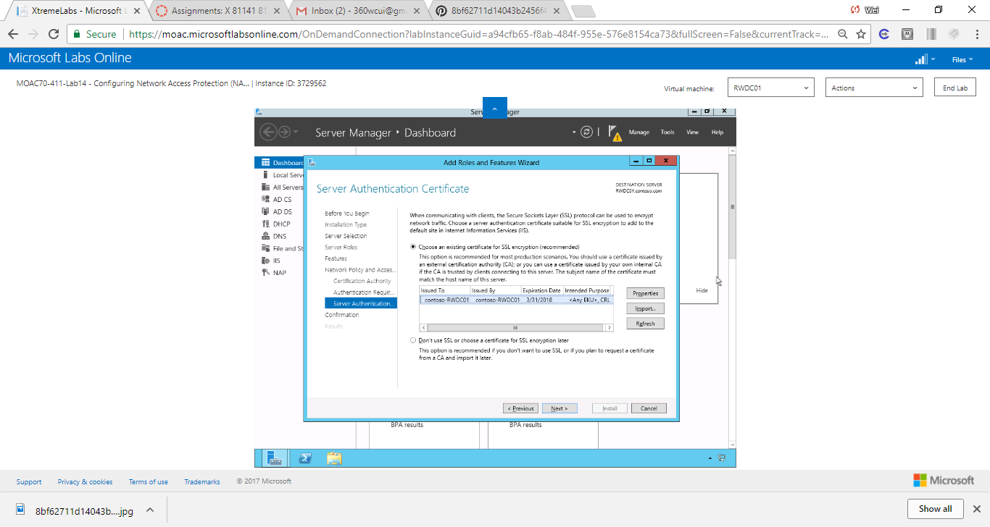

Figure 1 Screen shot shows RWDC01.contoso.com is the server on which the authentication certificate is used for SSL encryption

**14.** On the Confirm installation selection page, click Install.

**15.** When the installation is complete, click Close.

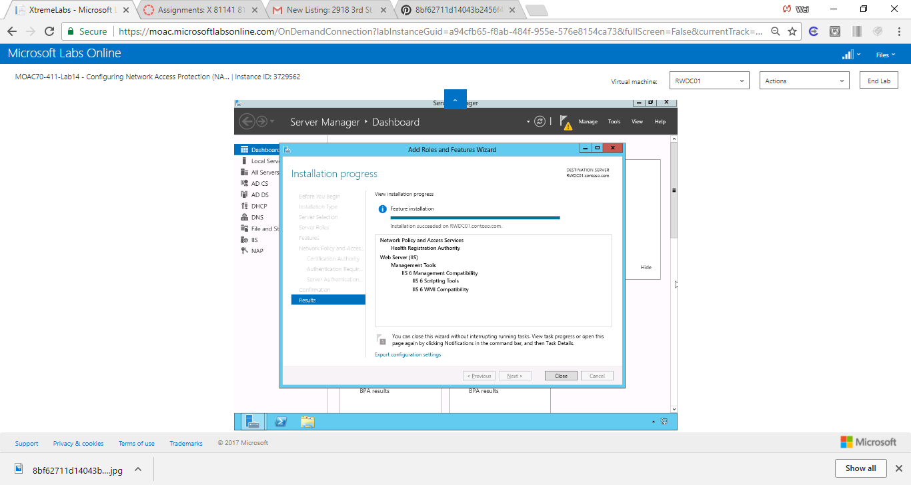

Figure 2 Screen shot shows installation complete for Health Registration Authority Role.

End of exercise.

**Lab Summary**

Configuring Network Access Protection (NAP), which is used to control who can access a network based on the security health of a client, is one of the most challenging. Before I can configure NAP, I must add the Health Registration Authority role to the current NPS installation on RWDC01 so that it can monitor the connections on the NPS server.

NAP is a policy-based management feature of Windows Server 2008 that allows a network administrator to control access to network resources.

An end user without the most recent malware protection, the latest operating system patches, a properly configured firewall, and other well-proven security measures can pose a significant risk to the corporate network. NAP policies ensure that these and other features are in place and current before the endpoint device is allowed access to the network. Devices that are not in compliance may have their access restricted or blocked entirely.